**Programming Exercises**

1. **In spatial domain, denoising pepper&salt noises by average, median and Gaussian filters, respectively, input noised image is as follows (noised Lena photo).**

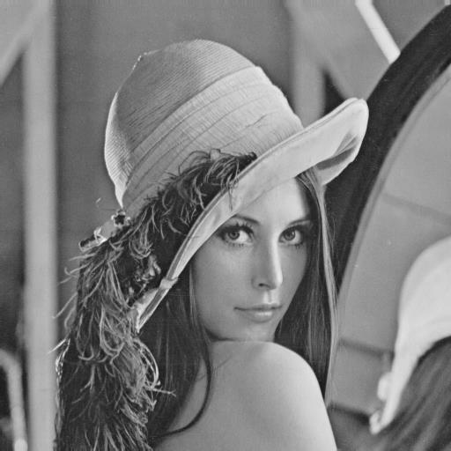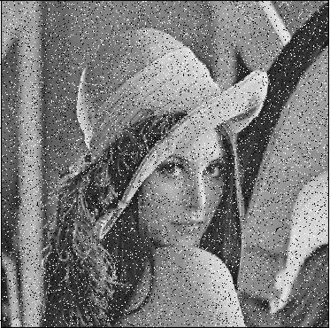

**Fig. Denoising: (a) Lena photo, (b) noised Lena photo (pepper&salt).**

A1: flowchart of average filter:

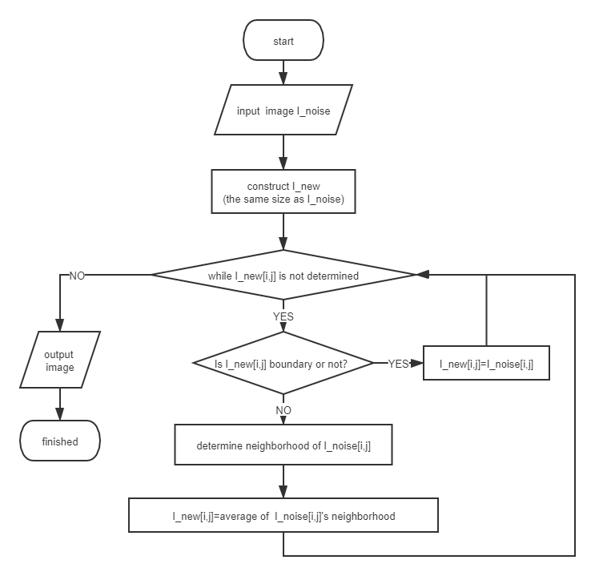

A2: flowchart of median filter:

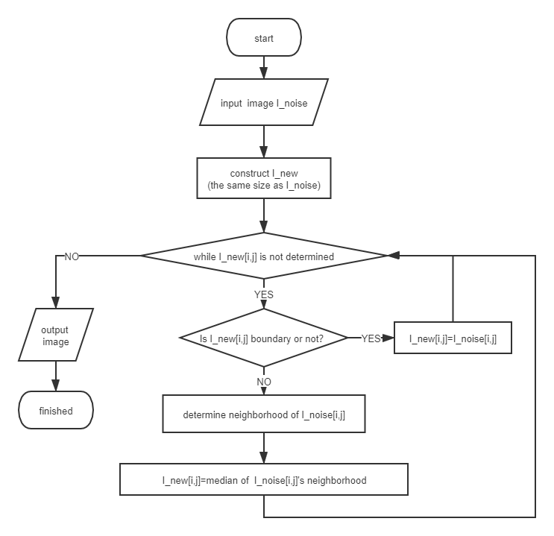

A3: flowchart of Gaussian filter :

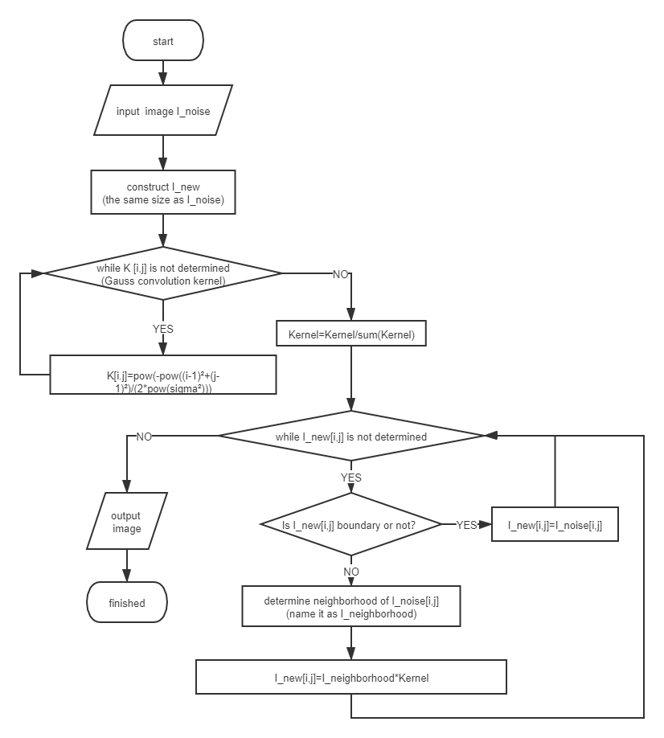

Summary:

Neighborhood refers to the set of pixels within a certain distance around the certain pixel. In the code, I selected the square with side length of 7 as the neighborhood.

Average of neighborhood refers to average the pixels in the neighborhood, median of neighborhood refers to find the median pixel in the neighborhood, and I_neighborhood*Kernel means weighted sum of points in neighborhood with Guassian. Here are the results:

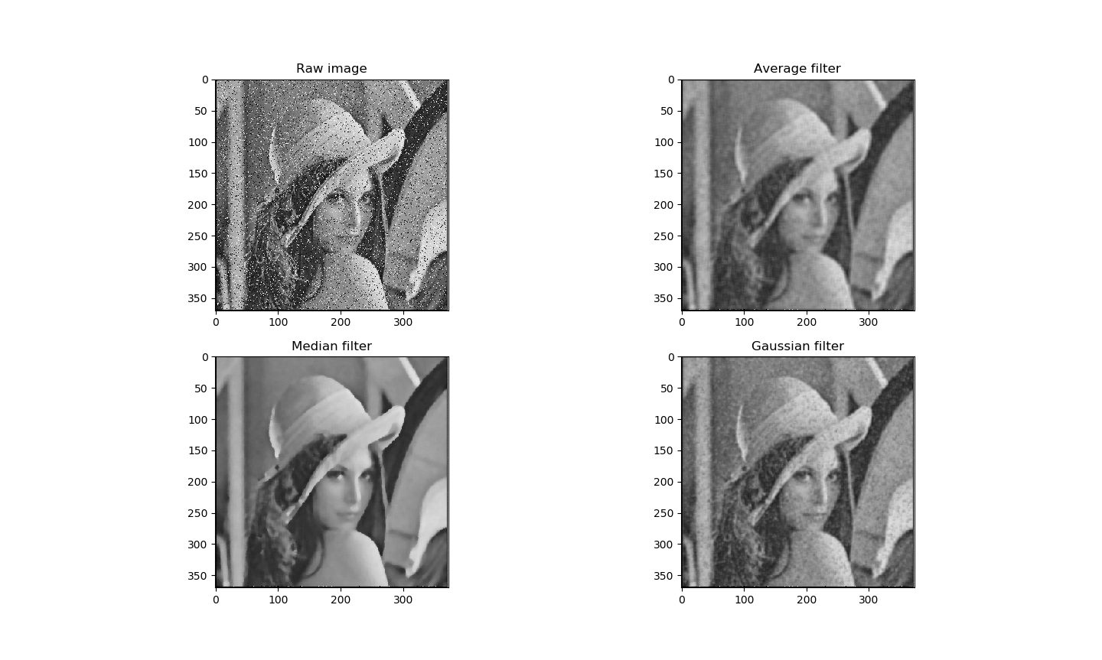

1. **Computing FT of the image given in problem1 and drawing its spectrum. And in frequency domain, denoising pepper & salt noises average, median, and Gaussian filters.**

A1:Here is the algorithm and the spectrum:

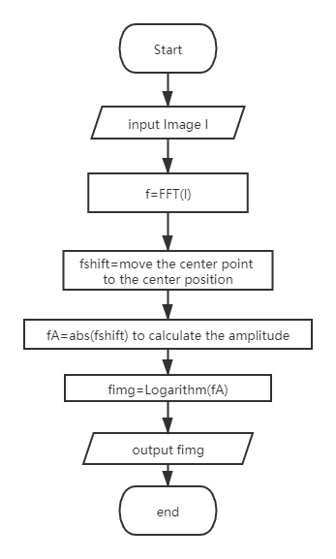

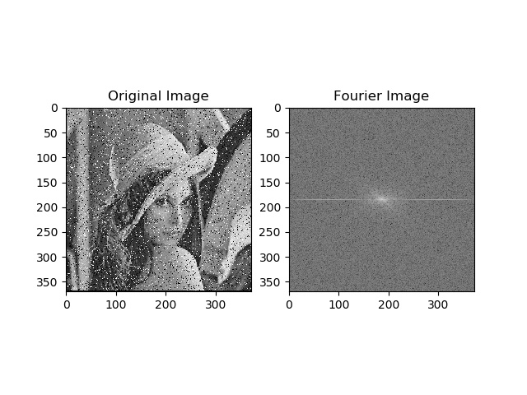

A2: The key of the algorithm is to confirm the noise——We think that the point with large amplitude is likely to be noise. We set a threshold, and we use filter to filter it when the amplitude of the pixel is greater than this threshold:

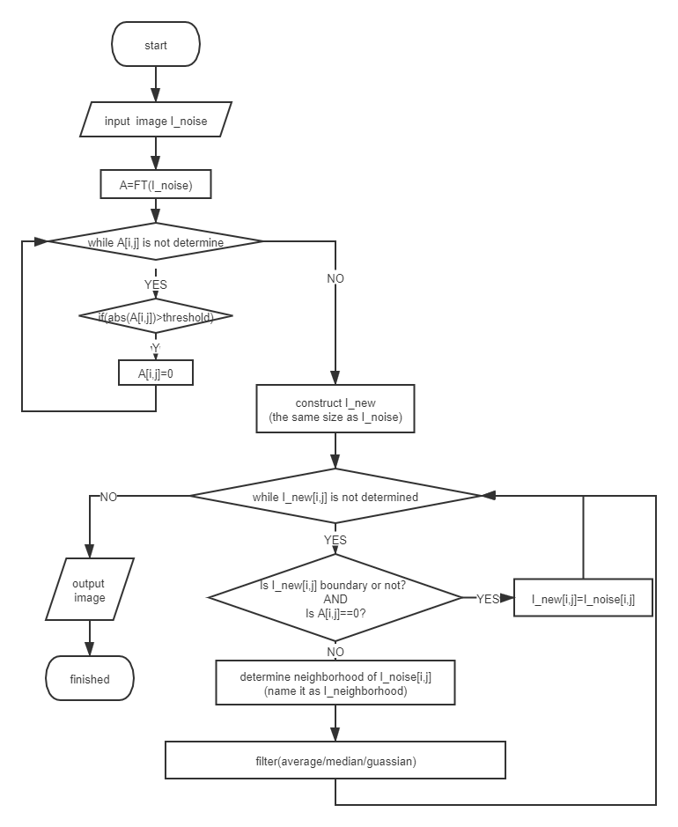

A3:Summary:

When the threshold value is 2000, the noise reduction effect is as follows:

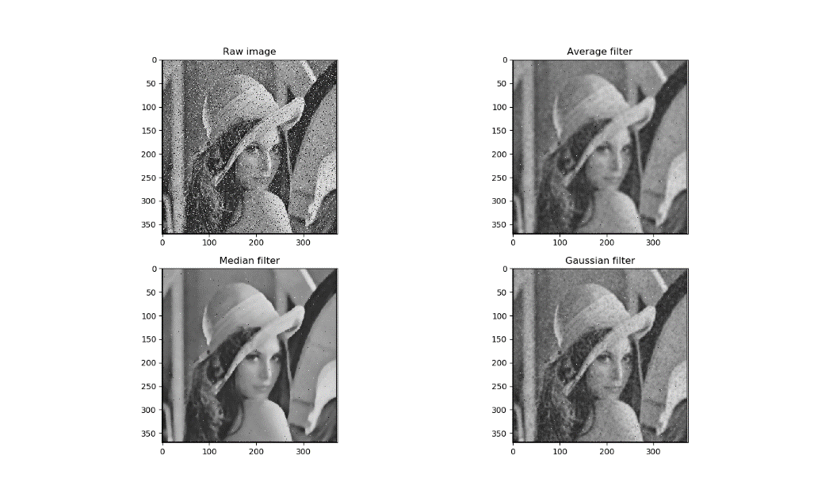

1. **Give the HPF and LPF resultant images of the above denoised image given in problem1.**

A1: HPF, the main work is to construct the filter:

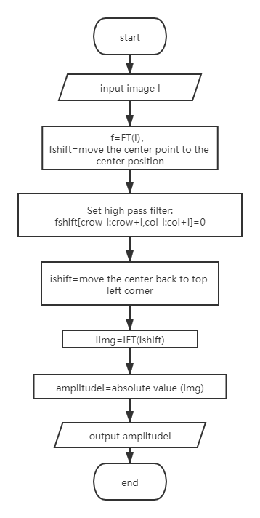

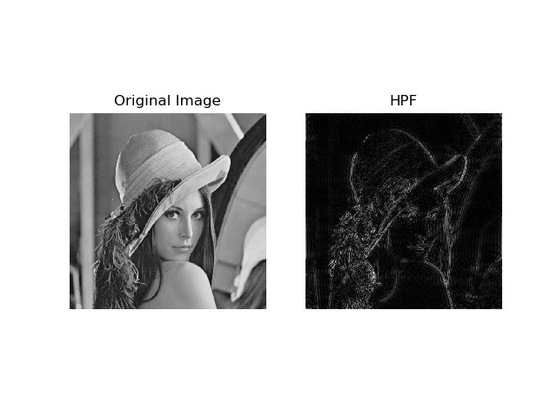

A1: LPF,the main work is to construct the filter:

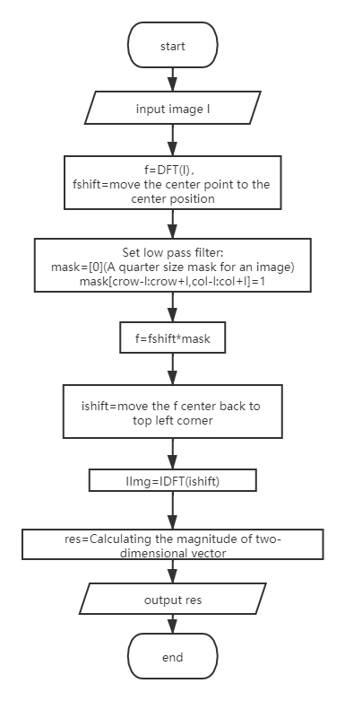

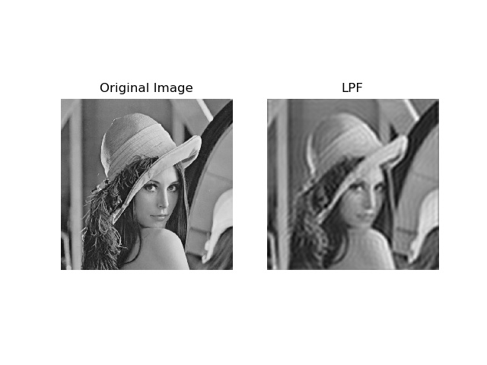

PS: Source code and result images are attached to the compressed package.